**DOCKER ASSIGNMENT-4**

**DEPLOY ‘gameoflife.war’ on Tomcat-9 container using docker-compose.yml using JENKINS DECLARATIVE PIPELINE -**

**Master-Slave Configuration**

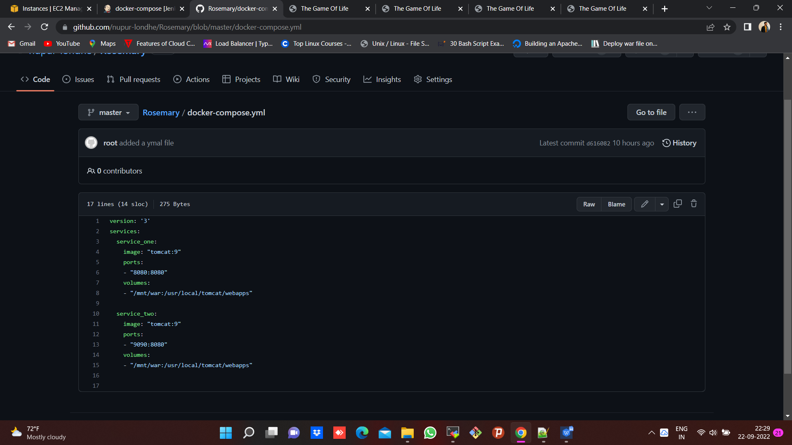

* Docker compose yaml script for Tomcat server on Github

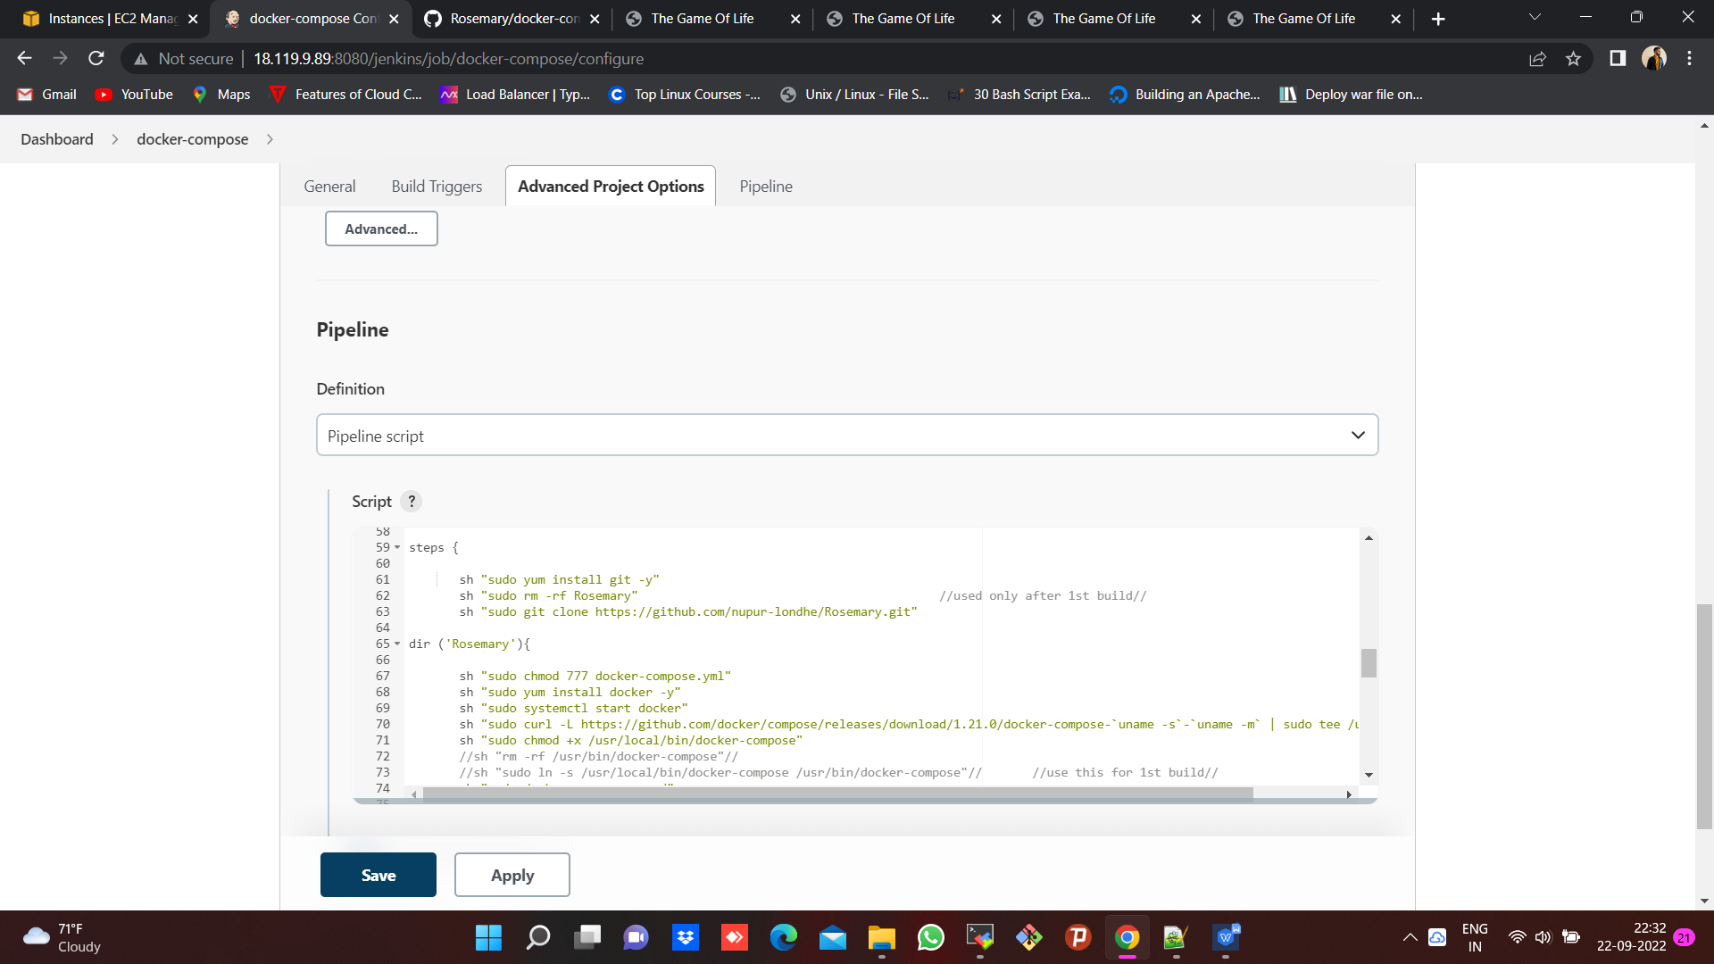

* JENKINS declarative pipeline script (full script available at bottom of this doc)

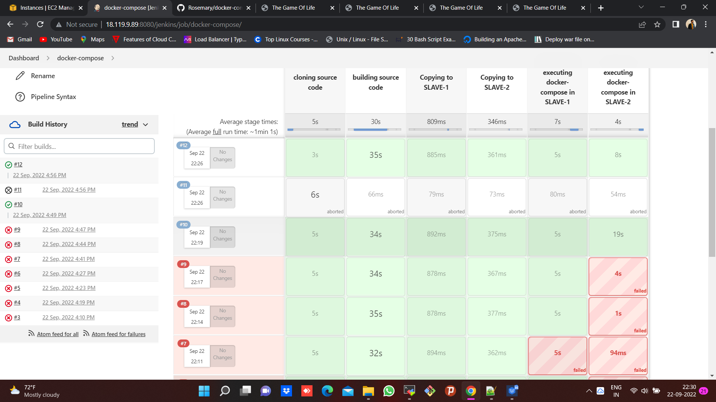

* Build success after multiple troubleshooting and modifying the pipeline.

-----------------------------------------------------------------------------------------------------------------

**OUTPUT :** To host/deploy gameoflife.war application on slave machines at port nos. of 8080 & 9090 of each slave using docker compose yaml script and pipeline.

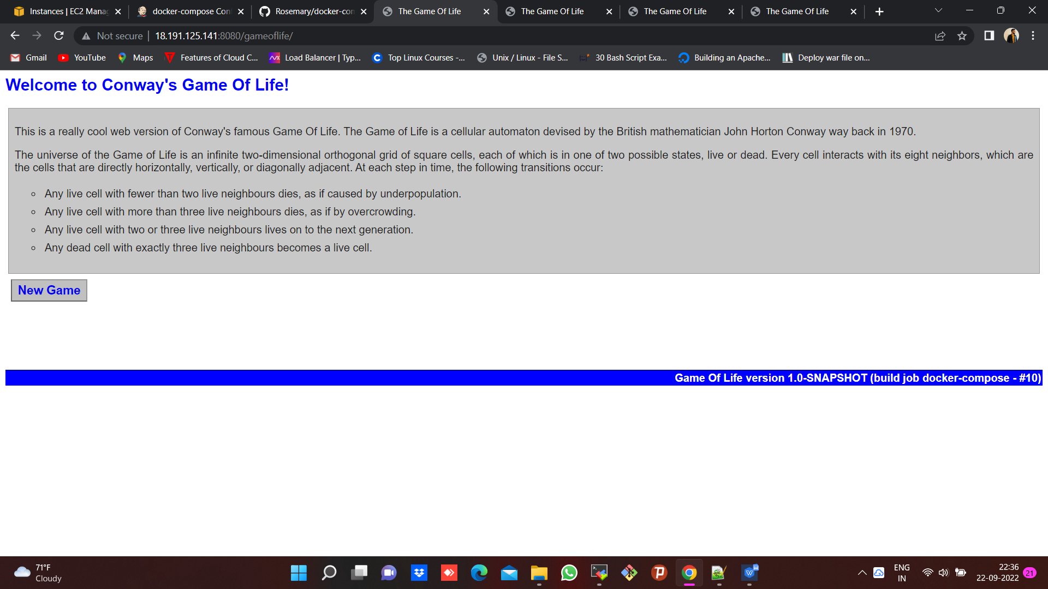

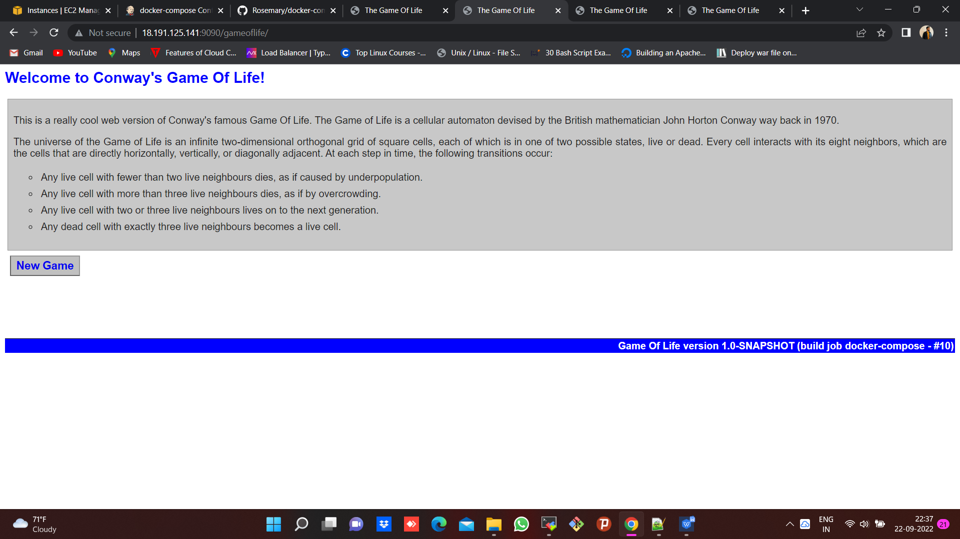

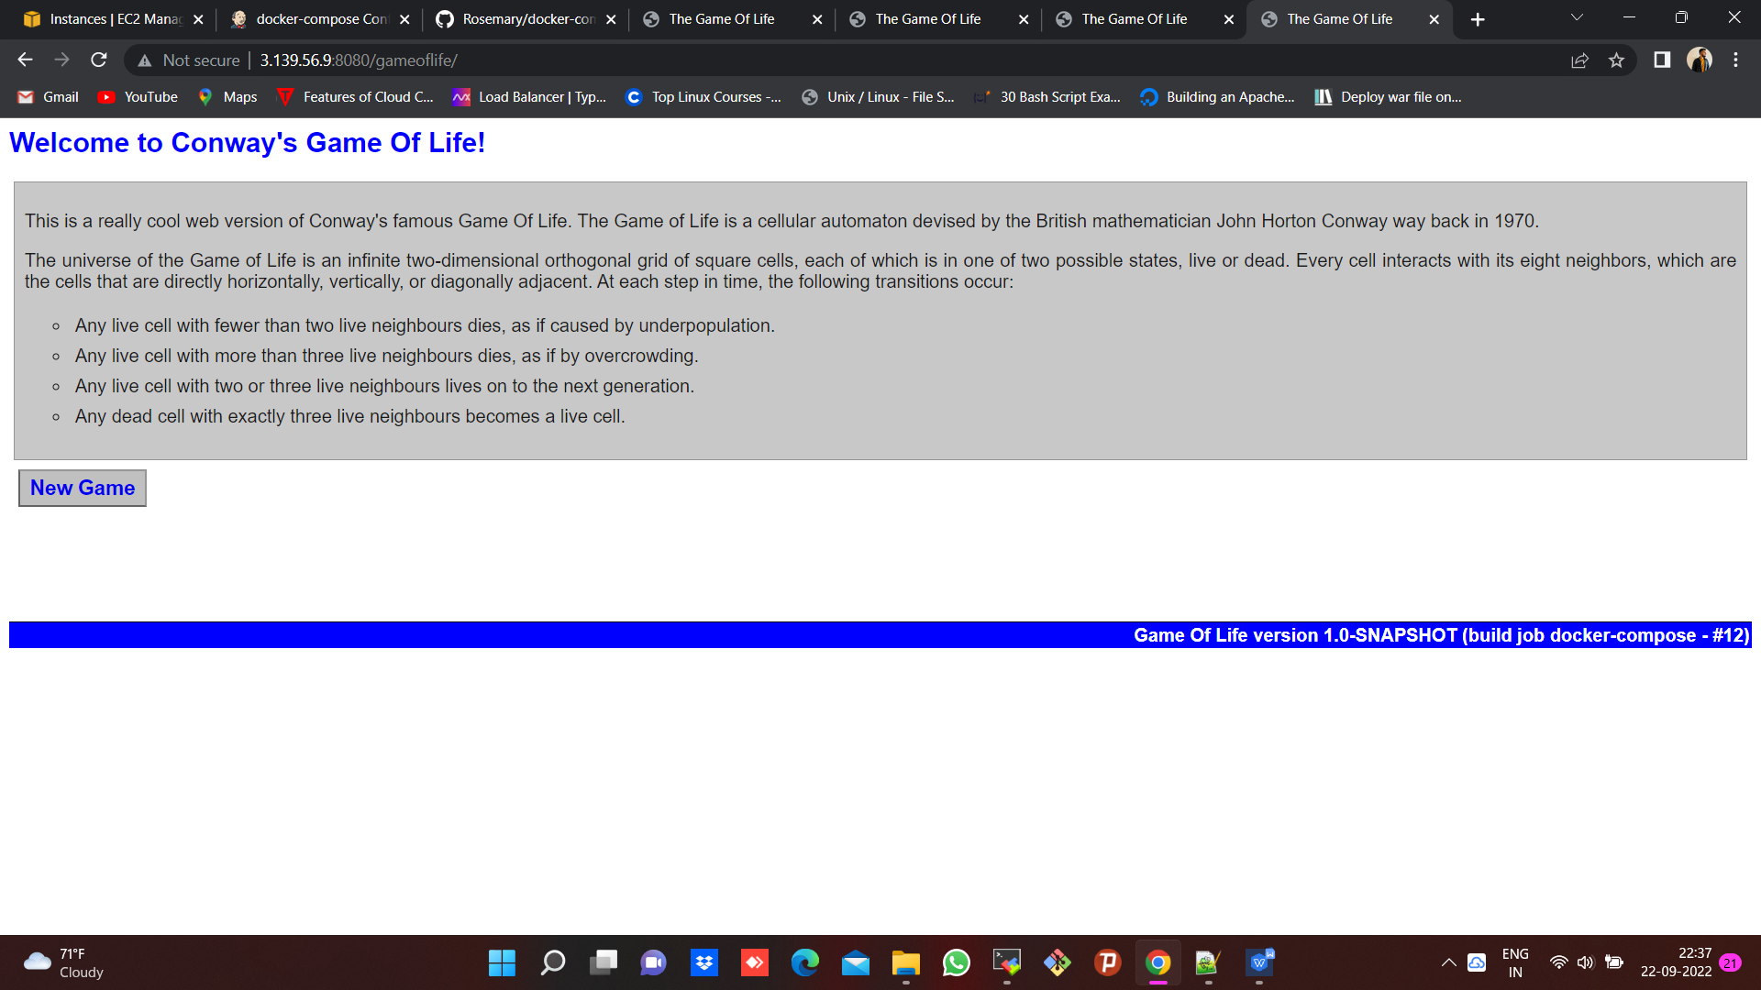

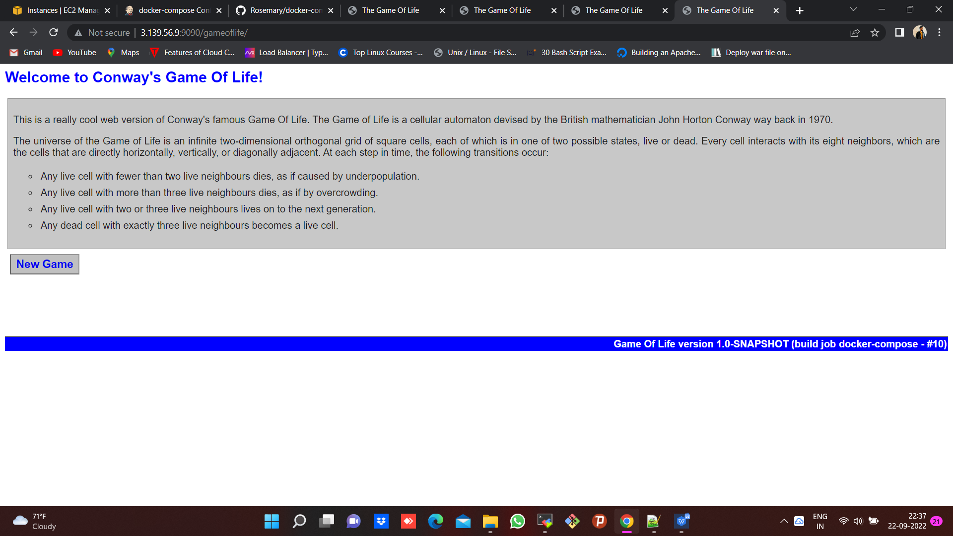

**CODE**

pipeline {

agent {

node {

label "built-in"

customWorkspace "/mnt/projects"

}

}

stages {

stage ('cloning source code') {

steps {

sh "rm -rf *"

sh "yum install git -y"

sh "git clone https://github.com/nupur-londhe/game-of-life-nup.git"

sh "chmod 400 /mnt/ohio.pem"

}

}

stage ('building source code') {

steps {

dir ('/mnt/projects/game-of-life-nup'){

sh "mvn install"

}

}

}

stage ('Copying to SLAVE-1') {

steps {

dir ('/mnt/projects/game-of-life-nup') {

sh "cp /mnt/ohio.pem /mnt/projects/game-of-life-nup"

sh "scp -i ohio.pem gameoflife-web/target/gameoflife.war ec2-user@172.31.19.233:/mnt/war" //give 777 permissions for /mnt/war//

}

}

}

stage ('Copying to SLAVE-2') {

steps {

dir ('/mnt/projects/game-of-life-nup') {

sh "scp -i ohio.pem gameoflife-web/target/gameoflife.war ec2-user@172.31.16.157:/mnt/war" //give 777 permissions for /mnt/war//

}

}

}

stage ('cloning and executing docker-compose in SLAVE-1'){

agent{

node {

label "172.31.19.233-SLAVE-1"

customWorkspace "/mnt/nupur"

}

}

steps {

sh "sudo yum install git -y"

sh "sudo rm -rf Rosemary" //used only after 1st build//

sh "sudo git clone https://github.com/nupur-londhe/Rosemary.git"

dir ('Rosemary'){

sh "sudo chmod 777 docker-compose.yml"

sh "sudo yum install docker -y"

sh "sudo systemctl start docker"

sh "sudo curl -L https://github.com/docker/compose/releases/download/1.21.0/docker-compose-`uname -s`-`uname -m` | sudo tee /usr/local/bin/docker-compose > /dev/null"

sh "sudo chmod +x /usr/local/bin/docker-compose"

//sh "rm -rf /usr/bin/docker-compose"//

//sh "sudo ln -s /usr/local/bin/docker-compose /usr/bin/docker-compose"// //use this for 1st build//

sh "sudo docker-compose up -d"

}

}

}

stage ('cloning and executing docker-compose in SLAVE-2'){

agent{

node {

label "172.31.16.157-SLAVE-2"

customWorkspace "/mnt/nupur"

}

}

steps {

sh "sudo yum install git -y"

sh "sudo rm -rf Rosemary" //used only after 1st build//

sh "sudo git clone https://github.com/nupur-londhe/Rosemary.git"

dir ('Rosemary'){

sh "sudo chmod 777 docker-compose.yml"

sh "sudo yum install docker -y"

sh "sudo systemctl start docker"

sh "sudo curl -L https://github.com/docker/compose/releases/download/1.21.0/docker-compose-`uname -s`-`uname -m` | sudo tee /usr/local/bin/docker-compose > /dev/null"

sh "sudo chmod +x /usr/local/bin/docker-compose"

//sh "sudo ln -s /usr/local/bin/docker-compose /usr/bin/docker-compose"// //use this for 1st build//

sh "sudo docker-compose up -d"

}

}

}

}

}